Sugar Jar Cap

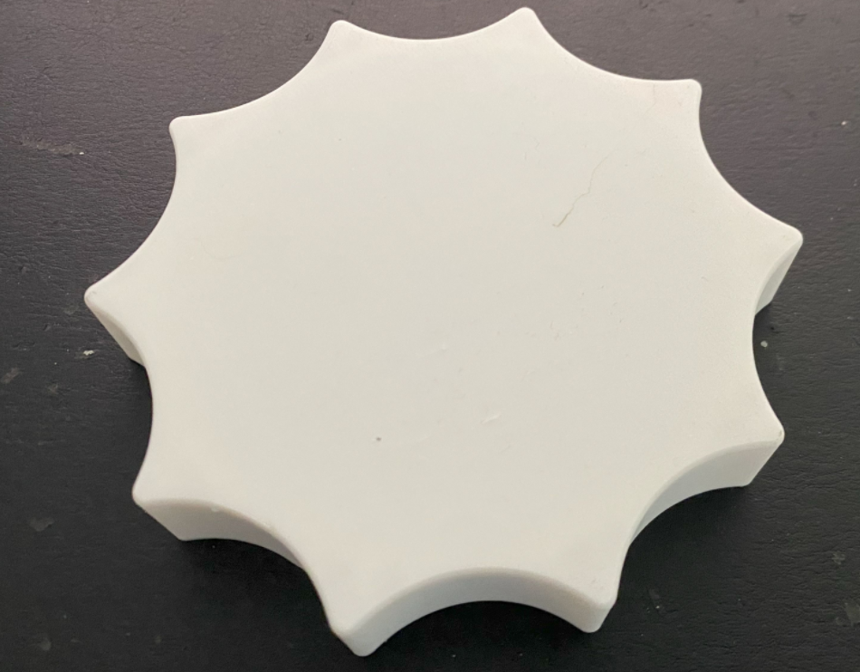

Version 2.0

Project Goals
Create a replacement cap for a sugar jar.
This is the version 2.0 that improve the first one adding rounded corners.
The original one has a very bad handling feeling.

Drawings
There is an internal dimension of 85,60 in the back and 86 mm in the top.
The 0.40 mm of step is used to improve the hold on the gasket.
The external grip is made using a circular sequence of 10 construction lines.
And the rounded grip is simple an arc from 3 points repetead circularly for 10 times.
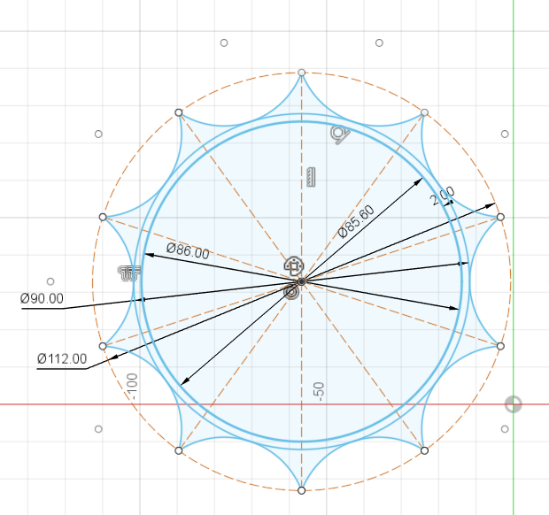

Extrusion
The back plane is just 2 mm
The main body is 19 mm
The middle size is just 10 mm
All edges are rounded with 2 mm radius
The upper profile is just 1 mm radius rounded
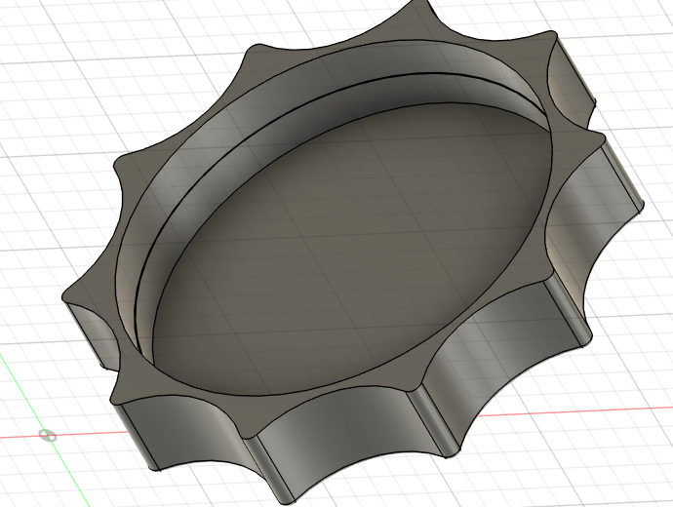

Final Result
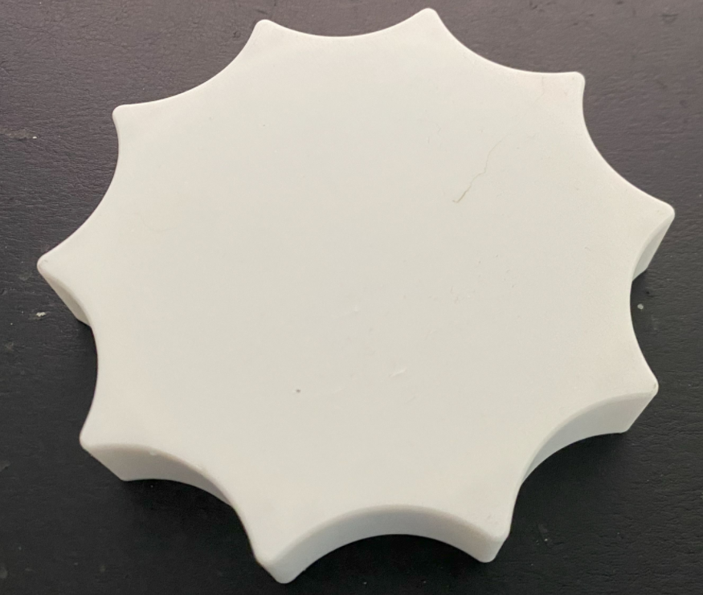 | 